Refered Udemy Course. For training and Angular .io

**Connections to Php PDO: connecting to php Data object**

Refered Php MDN.

<http://php.net/manual/en/pdo.connections.php>

PHP data object notation:

It works as a object and use scope resoultuion method to connect to an access an object.

To find the available drivers

<?php>

PD0::getAvailableDrivers();

Print_r(PDO:: PD0::getAvailableDrivers());

<php>

Connectiond to PDO::

$conn =new PDO(‘drivername’,’dbname’,’username’,’password’)’

Put this in try catch mode to avoid the uncall exceptions.and add handler attributedescribing the type of error

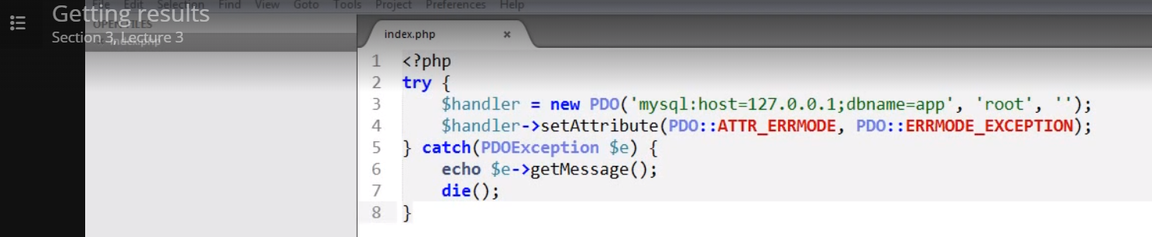

We can write queries and retrive them as we watnt

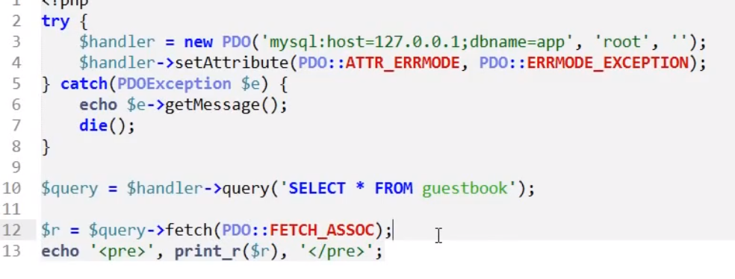

Other tyPe we can use fetch_Num,fetch_array.fetch_both

**Since this this PDO is object oriented we can use $result}28067359+/8**

**+6*9+\7=$query->(PO::FETCH_OBJ);**

* -> is used to acces the object properties.

Its easy to return an array of objects.

**Fetching Data into a Class:**

Creating a class and use the method in the class .

We create a clas and declare the variables along with the constructor and in

$query->setFetch0ode(PDO::FETch_class,fetch_Assoc (,classname,):

This return the data as a class .

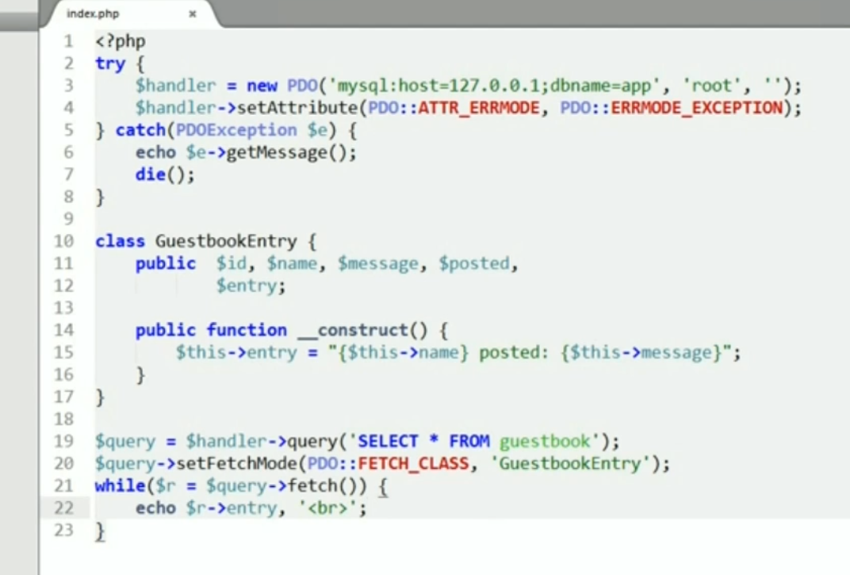

Fetching all data from the :

We use fetchAll

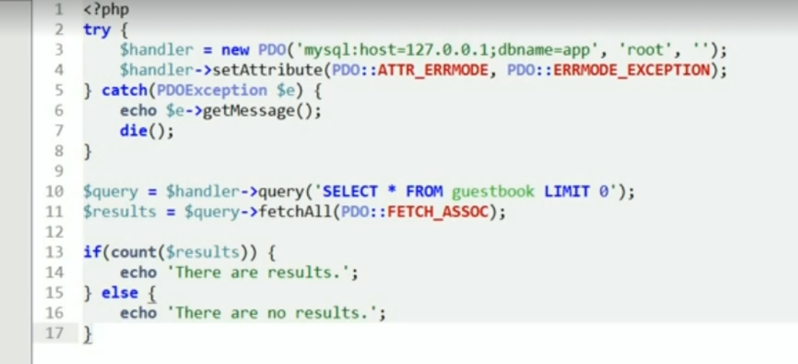

Last inserted iD:

Getting the last inserted ID ia at the handler level not the query level.

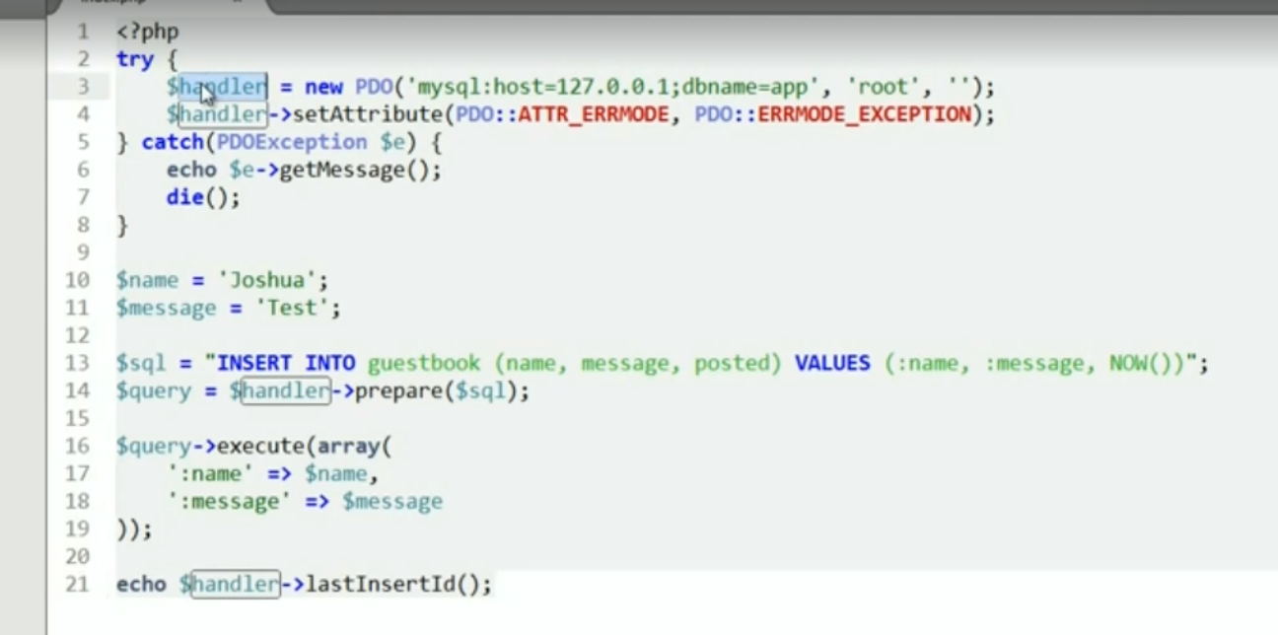

Getting the row count

